Enterprise SOC Home Lab
Using Wazuh SIEM

Pavan N
Cybersecurity Analyst | Detection Engineer
LinkedIn: pavan-n-cosmic | GitHub: Pavan-glitch22
June 2026

Abstract
This project documents the design, deployment, configuration, and testing of a Security Operations Center (SOC) Home Lab using Wazuh SIEM. The objective was to gain practical, hands-on experience in security monitoring, threat hunting, detection engineering, log analysis, and incident investigation. The lab was built using Ubuntu Server 26.04 LTS as the Wazuh Manager, Kali Linux 2026.2 as the monitored endpoint and attack simulation machine, and VirtualBox as the virtualization platform.

Throughout the project, multiple real-world challenges were encountered and resolved — including network configuration issues, Wazuh installation requirements, storage limitations, dashboard accessibility, agent deployment, and custom rule creation. The final environment delivered a fully functional SOC platform capable of centralized log collection, alert generation, threat hunting, authentication monitoring, and custom detection engineering.

1. Introduction
Modern organizations generate enormous volumes of security-related logs from servers, workstations, applications, firewalls, and cloud platforms. Security Operations Centers (SOCs) use Security Information and Event Management (SIEM) platforms to collect, normalize, correlate, and investigate these events at scale.

Wazuh is an open-source SIEM and Extended Detection and Response (XDR) platform that provides:
- Log Collection and Normalization
- Threat Detection and Alerting
- File Integrity Monitoring (FIM)
- Vulnerability Detection
- Threat Hunting
- Compliance Monitoring (PCI-DSS, HIPAA, GDPR, TSC)
- Incident Investigation

The purpose of this project was to build a realistic, enterprise-style SOC environment and gain hands-on experience with security monitoring and detection engineering — skills directly relevant to SOC Analyst L1 roles.

2. Project Objectives
# | Description
Objective 1 | Deploy Wazuh SIEM on Ubuntu Server 26.04 LTS
Objective 2 | Configure VirtualBox networking (NAT + Internal Network)
Objective 3 | Deploy and register Wazuh Agents on monitored endpoints
Objective 4 | Perform threat hunting using the Wazuh dashboard
Objective 5 | Create custom detection rules (Detection Engineering)
Objective 6 | Simulate real-world attacks and verify alert generation
Objective 7 | Practice SOC analyst workflows: triage, investigation, response

3. Lab Architecture
The SOC lab consists of three virtual machines hosted on VirtualBox, all communicating over a shared Internal Network named SOC-LAB.

Component | Role / IP
Ubuntu Server 26.04 | Wazuh Manager, Dashboard, Indexer — IP: 192.168.56.10
Kali Linux 2026.2 | Attack Simulation Machine + Wazuh Agent — IP: 192.168.56.20
Metasploitable 2 | Vulnerable Target Machine — IP: 192.168.56.30
Windows 10 | Additional monitored endpoint (optional)

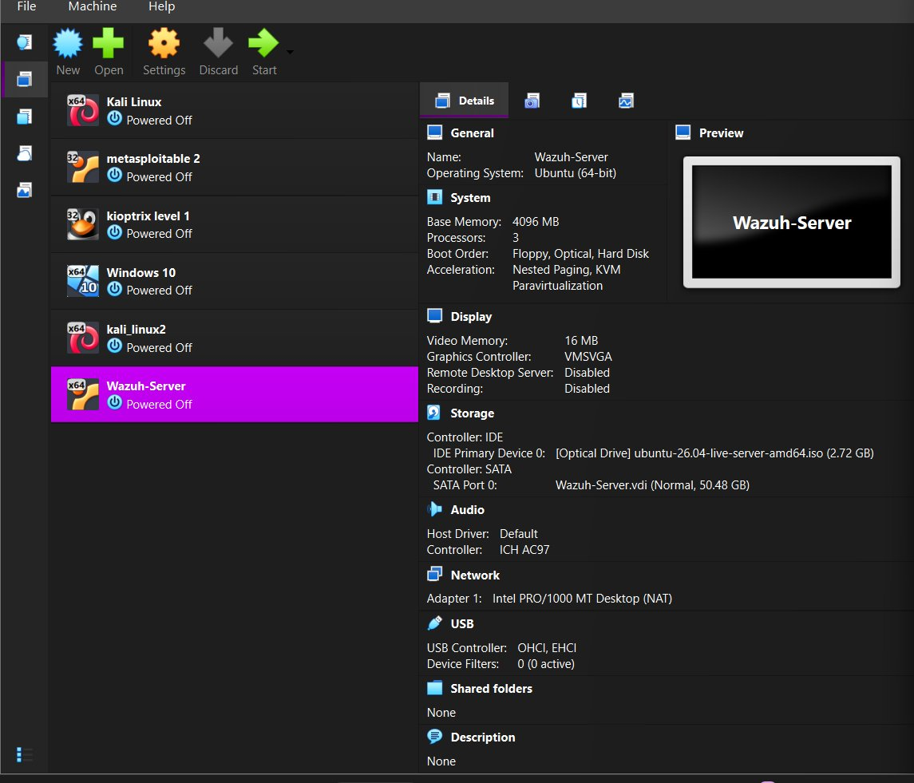
Figure: VirtualBox VM inventory — all lab machines

3.1 Network Architecture
Each virtual machine was configured with two network adapters:

Adapter | Purpose
Adapter 1 | NAT — Internet access (package downloads, updates)
Adapter 2 | Internal Network "SOC-LAB" — Isolated SOC communications

This design separates internet connectivity from internal SOC communications, replicating a real network segmentation model.

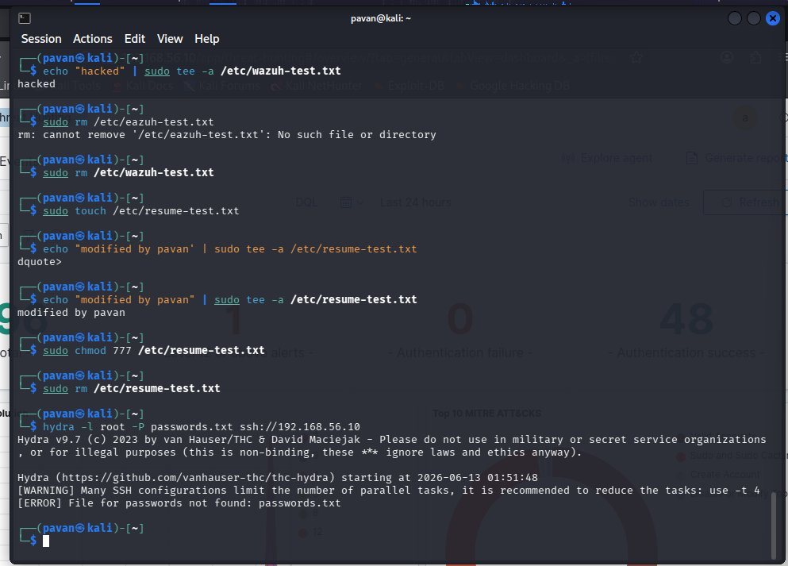
Figure: Kali Linux network settings — Adapter 1 NAT
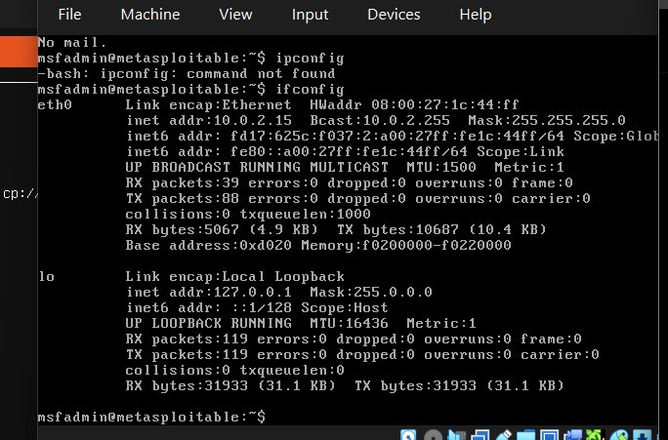
Figure: Windows 10 — Internal Network SOC-LAB configuration

4. Wazuh Server Setup

4.1 Ubuntu Server Installation
Ubuntu Server 26.04 LTS was installed as the Wazuh Manager host. It features the Linux 7.0 kernel and 5 years of free security updates.

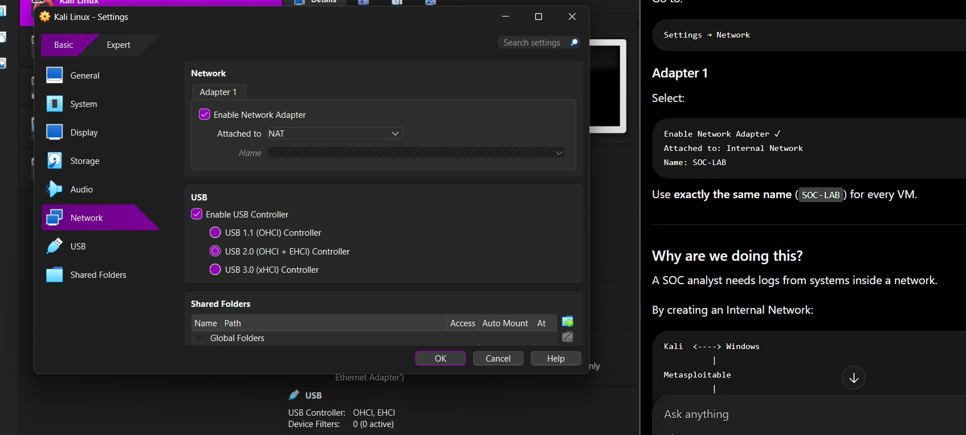
Figure: Ubuntu Server 26.04 LTS download page
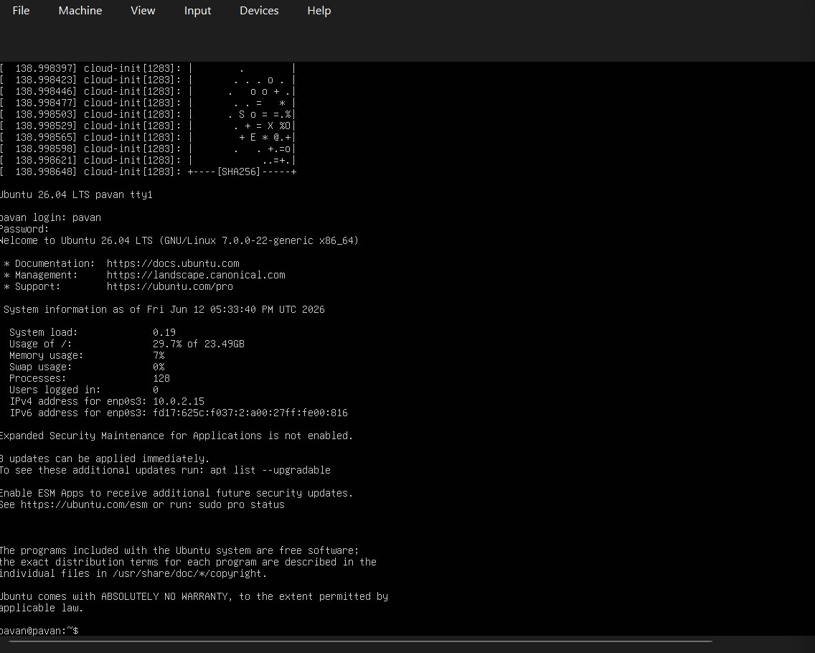
Figure: Wazuh-Server VM configuration — 4GB RAM, 50GB disk, Ubuntu 64-bit

4.2 Wazuh All-in-One Installation
The Wazuh All-in-One installer was used to deploy the complete stack — Manager, Dashboard, and Indexer — in a single operation.

curl -sO https://packages.wazuh.com/4.12/wazuh-install.sh
chmod +x wazuh-install.sh
sudo ./wazuh-install.sh -a

The deployment process took approximately 20–30 minutes and automatically configured all three components.

4.3 Installation Challenges

Hardware Requirement Issue
Problem | Installer reported insufficient system resources
Error | System does not meet recommended minimum hardware requirements
Cause | Ubuntu VM was configured with insufficient RAM
Solution | Increased memory allocation from 4 GB to 6 GB in VirtualBox settings
Result | Installation continued and completed successfully

Storage Expansion Challenge
Problem | Wazuh Indexer entered read-only mode
Error | Flood-stage watermark exceeded
Finding | Ubuntu was only using 24 GB of the 50 GB virtual disk
Fix | sudo lvextend -l +100%FREE /dev/ubuntu-vg/ubuntu-lv
Fix | sudo resize2fs /dev/ubuntu-vg/ubuntu-lv
Result | Filesystem expanded; disk utilization issue resolved

Dashboard Accessibility
Problem | Dashboard was inaccessible from the host machine
Cause | Environment only had an Internal Network — no host-only adapter
Solution | Accessed the dashboard using the Kali browser at https://192.168.56.10
Result | Dashboard loaded successfully

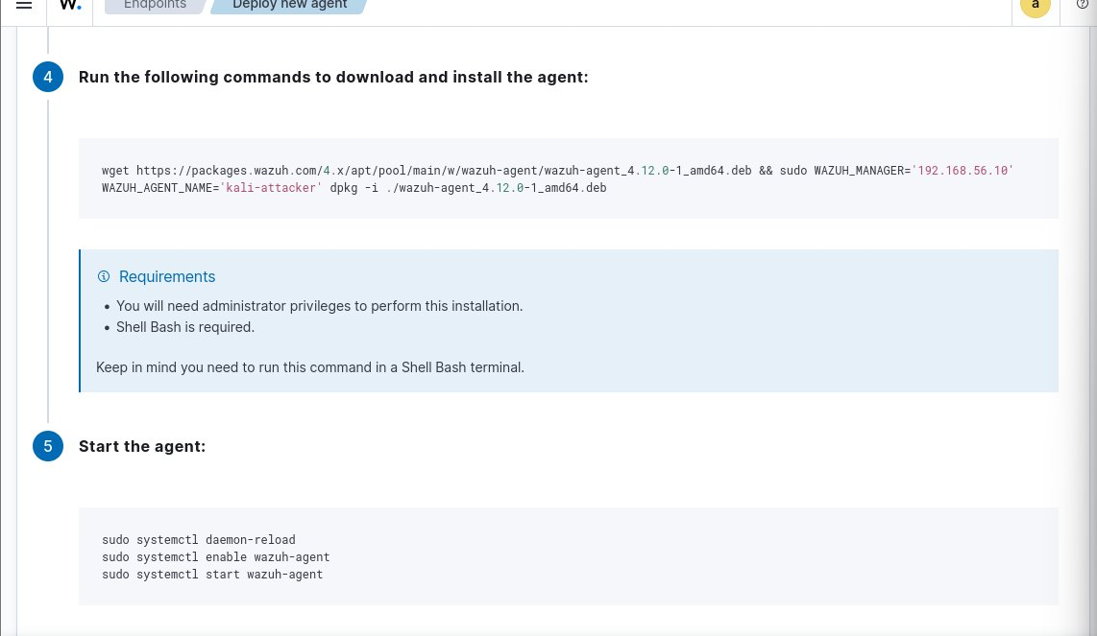
Figure: Wazuh Overview dashboard — first successful login

5. Network Configuration

5.1 IP Assignment
Static IP addresses were assigned to all VMs on the SOC-LAB internal interface.

Ubuntu Server (Wazuh Manager)
sudo ip addr add 192.168.56.10/24 dev enp0s8
sudo ip link set enp0s8 up

Kali Linux (Agent)
sudo ip addr add 192.168.56.20/24 dev eth1
sudo ip link set eth1 up

Metasploitable
ifconfig eth1 192.168.56.30 netmask 255.255.255.0 up

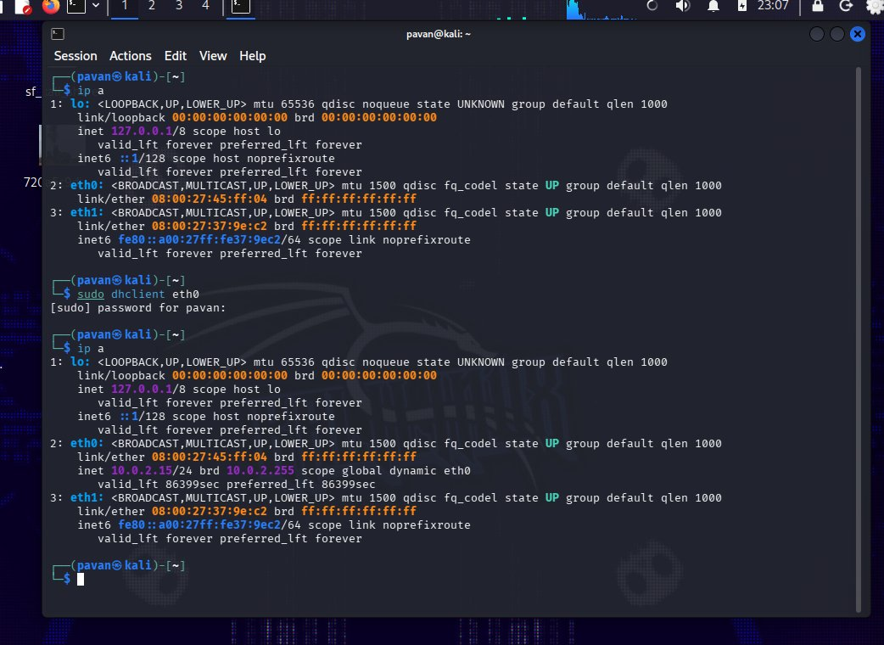
Figure: Kali Linux — ip a output confirming 10.0.2.15 (NAT) assignment
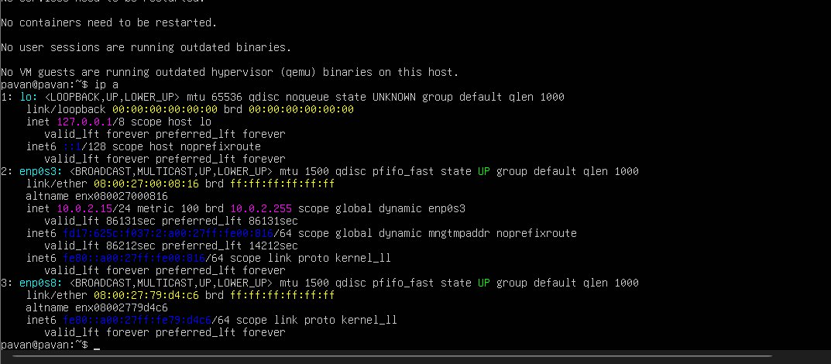
Figure: Ubuntu Server — login screen and ip a confirming network interfaces

5.2 Connectivity Verification
After IP assignment, connectivity was verified between all nodes:
ping 192.168.56.10 # Kali -> Wazuh Server
ping 192.168.56.20 # Ubuntu -> Kali
ping 192.168.56.30 # Kali -> Metasploitable

All systems successfully communicated over the SOC-LAB internal network, confirming correct VirtualBox networking configuration.

6. Wazuh Agent Deployment
The Wazuh agent was deployed on Kali Linux using the auto-generated command from the Wazuh dashboard Deploy New Agent wizard.

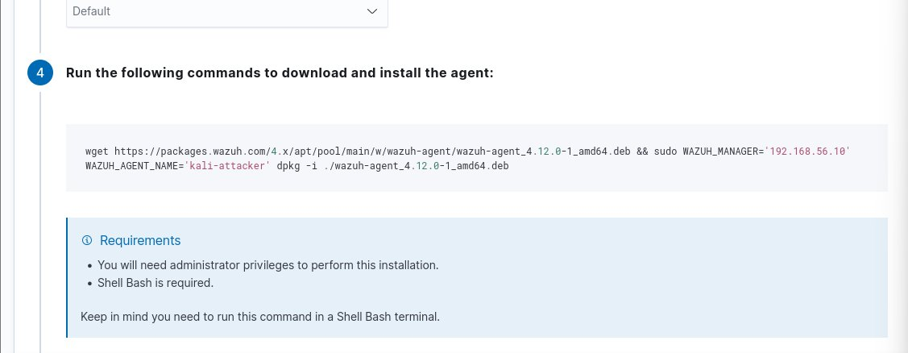
Figure: Wazuh — Deploy new agent wizard showing install command for kali-attacker

6.1 Installation Commands
wget https://packages.wazuh.com/4.x/apt/pool/main/w/wazuh-agent/wazuh-agent_4.12.0-1_amd64.deb \
&& sudo WAZUH_MANAGER='192.168.56.10' WAZUH_AGENT_NAME='kali-attacker' dpkg -i ./wazuh-agent_4.12.0-1_amd64.deb

6.2 Agent Service Startup
sudo systemctl daemon-reload
sudo systemctl enable wazuh-agent
sudo systemctl start wazuh-agent

6.3 Verification
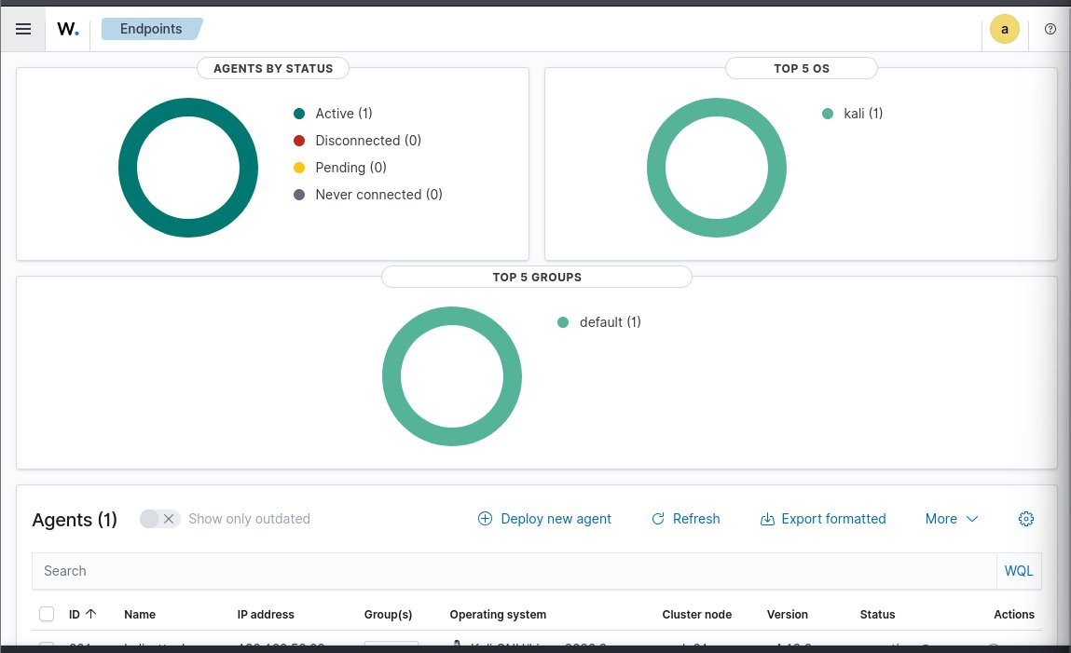
Figure: Wazuh Endpoints — kali-attacker registered and Active
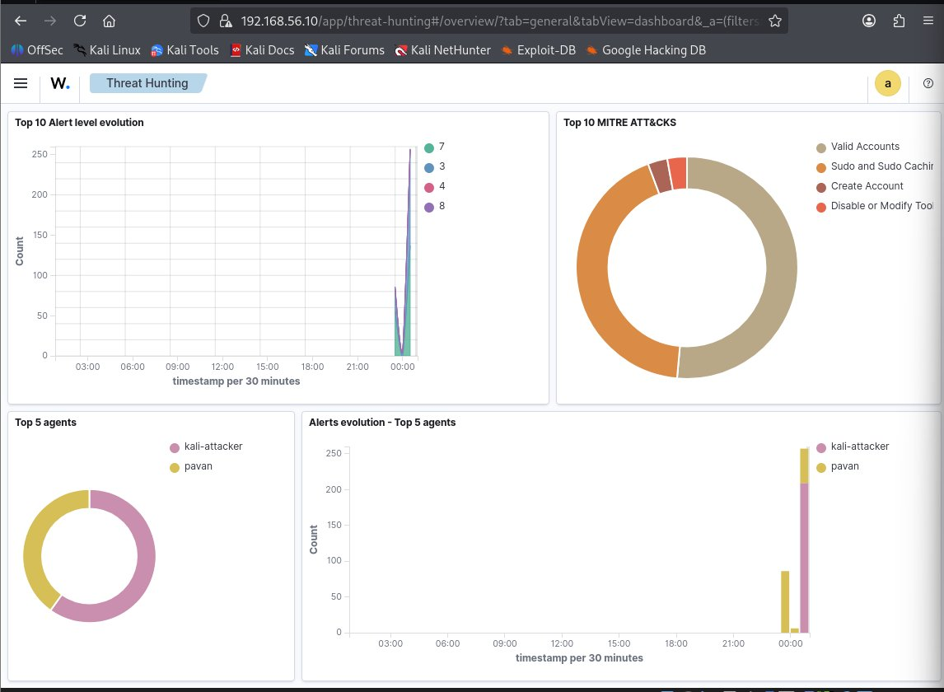
Figure: Agent detail — ID 001, Kali GNU/Linux 2026.2, v4.12.0, Active

Field | Value
Agent ID | 001
Agent Name | kali-attacker
IP Address | 192.168.56.20
OS | Kali GNU/Linux 2026.2
Wazuh Version | v4.12.0
Cluster Node | node01
Status | Active

7. Detection Engineering — Custom Rules
Creating custom detection rules is a core SOC analyst skill. Wazuh supports rule writing in XML format at /var/ossec/etc/rules/local_rules.xml.

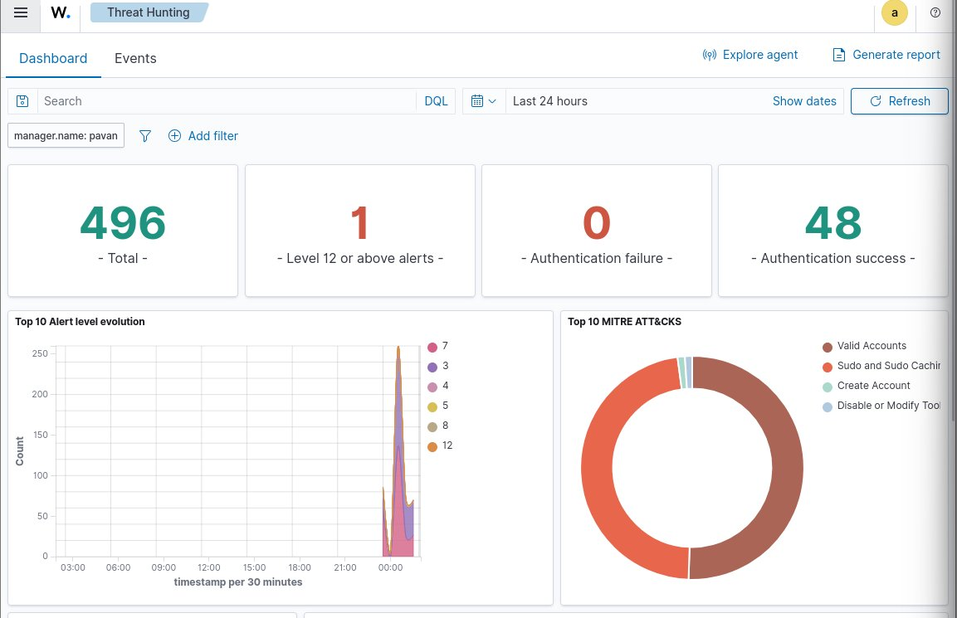
Figure: Wazuh rules manager — 4,491 built-in rules

7.1 Rules Written
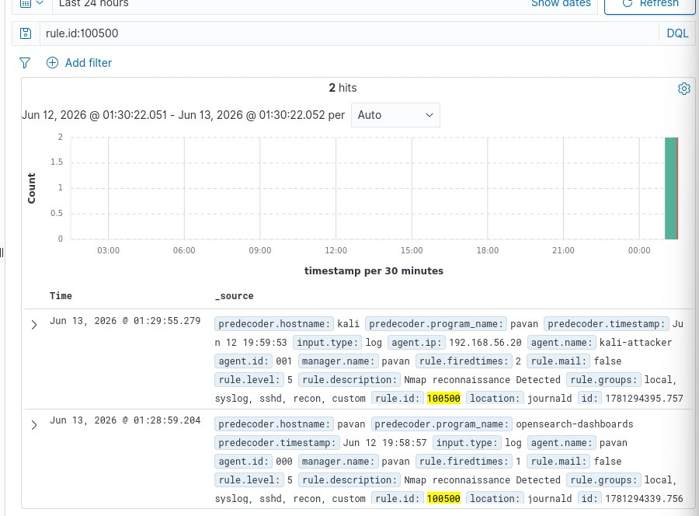
Figure: local_rules.xml — custom rules in nano editor

Rule 100001 — SSH Auth Failure from Specific IP
<rule id="100001" level="5">
<if_sid>5716</if_sid>
<srcip>1.1.1.1</srcip>
<description>sshd: authentication failed from IP 1.1.1.1</description>
<group>authentication_failed,pci_dss_10.2.4,pci_dss_10.2.5,</group>
</rule>

Rule 100500 — Nmap Reconnaissance Detection
<rule id="100500" level="5">
<match>nmap</match>
<description>Nmap reconnaissance Detected</description>
<group>recon,custom,</group>
</rule>

7.2 Deployment and Validation
sudo /var/ossec/bin/wazuh-analysisd -t # Validate rule syntax
sudo systemctl restart wazuh-manager # Apply rules

7.3 Rule Triggered — Nmap Scan Detection
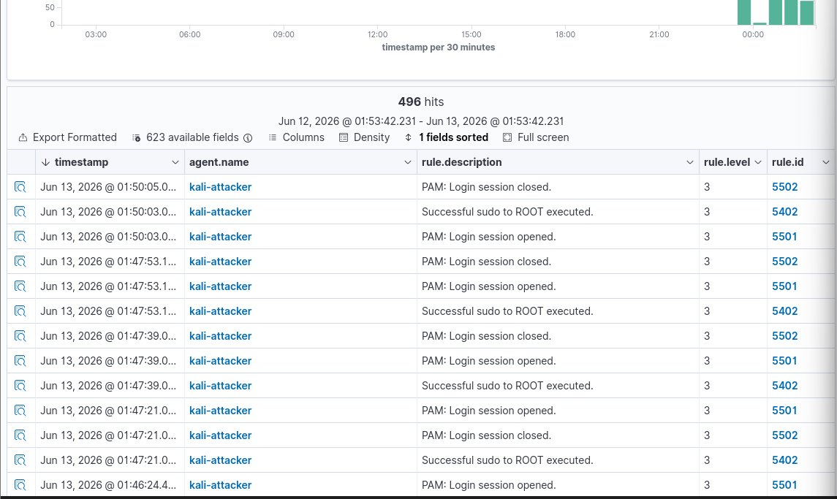
Figure: rule.id:100500 — 2 hits confirming Nmap reconnaissance detected

Field | Value
Rule ID | 100500
Level | 5
Description | Nmap reconnaissance Detected
Groups | local, syslog, sshd, recon, custom
Agent | kali-attacker
Trigger Source | journald logs containing "nmap" keyword

8. Threat Hunting
Threat hunting involves proactively searching through logs to detect malicious activity that may have evaded automated detection. The Wazuh Threat Hunting dashboard provides summary metrics, MITRE ATT&CK mapping, and per-agent alert breakdowns.

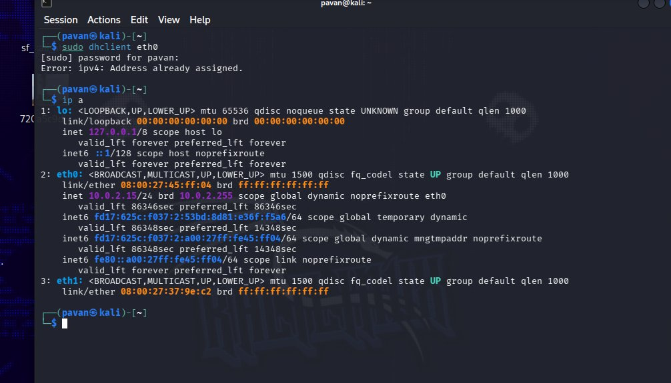
Figure: Threat Hunting dashboard — 481 total alerts, 1 Level 12 alert, 43 auth successes
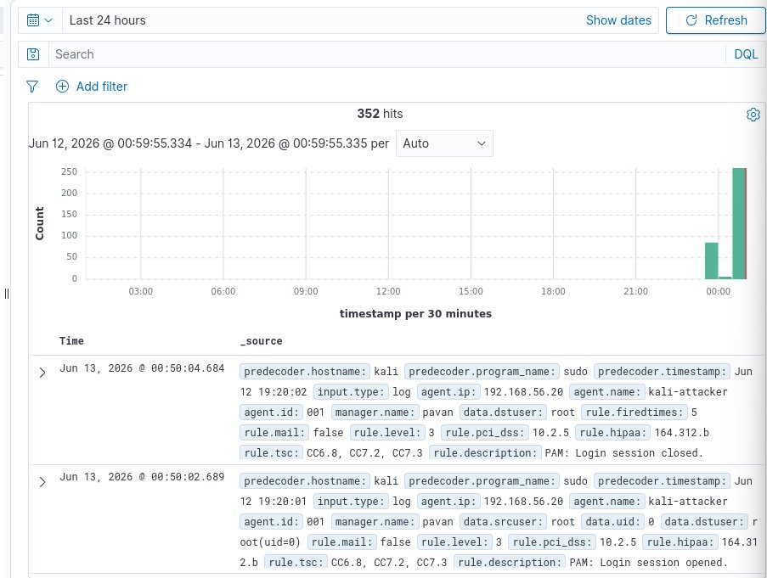
Figure: Threat Hunting dashboard — 496 total alerts snapshot during active simulation

8.1 Summary Metrics
Metric | Value
Total Alerts | 496
Level 12+ Alerts | 1 (High severity)
Authentication Failures | 0
Authentication Successes | 48
Primary Agent | kali-attacker

8.2 MITRE ATT&CK Mapping
The Top 10 MITRE ATT&CKs chart showed the following techniques detected:
- T1078 — Valid Accounts (largest segment)
- T1548.003 — Sudo and Sudo Caching
- T1136 — Create Account
- T1562 — Disable or Modify Tools

8.3 Event Investigation
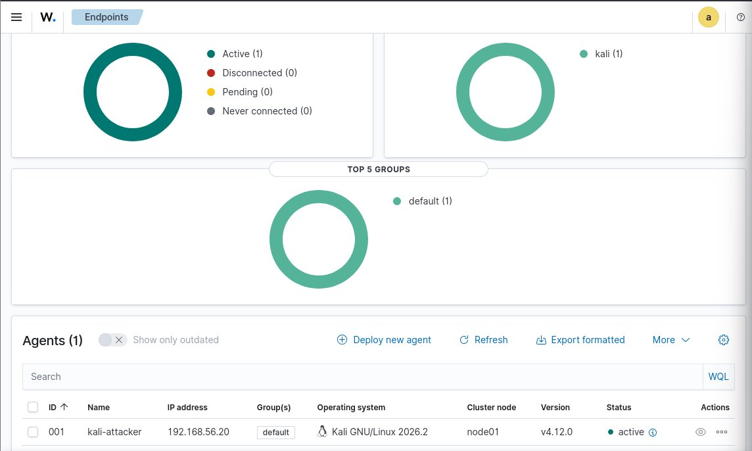
Figure: Threat Hunting events list — PAM sessions and sudo escalation alerts
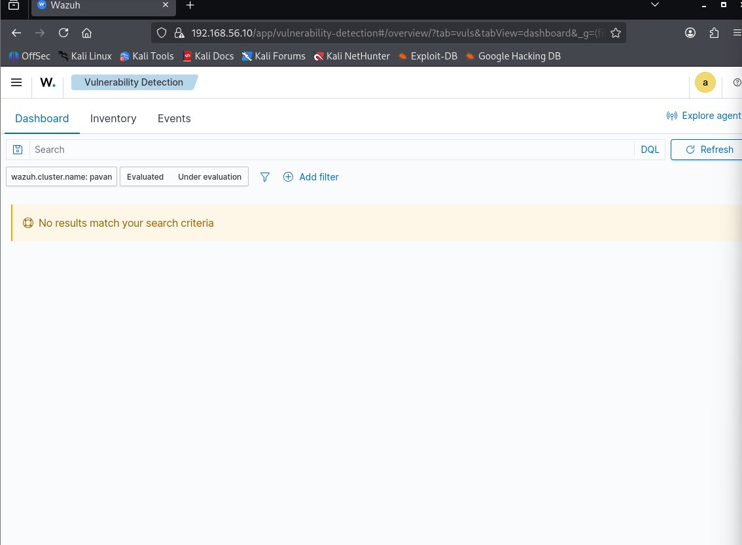
Figure: Wazuh Discover — 441 hits with full field breakdown

Rule ID | Description
Rule 5402 | Successful sudo to ROOT executed
Rule 5501 | PAM: Login session opened
Rule 5502 | PAM: Login session closed
Rule 100500 | Nmap reconnaissance Detected (custom)

8.4 Privilege Escalation Monitoring
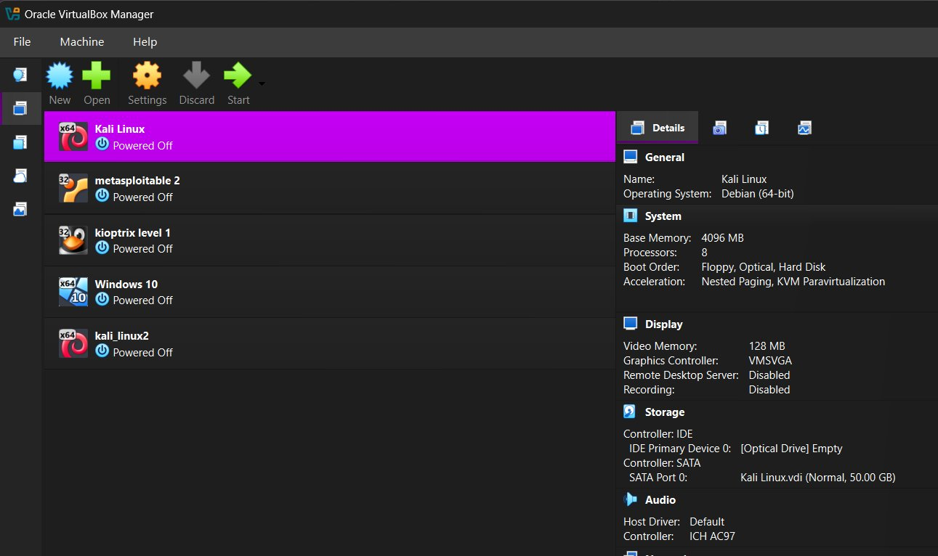
Figure: Rule 5402 detail — Successful sudo to ROOT, HIPAA 164.312.b, PCI-DSS 10.2.5

Every sudo execution was logged with full compliance mapping:
- GPG 13: 7.6, 7.8, 7.13
- GDPR: IV_32.2
- HIPAA: 164.312.b
- PCI-DSS: 10.2.5
- TSC: CC6.8, CC7.2, CC7.3

9. File Integrity Monitoring (FIM) & Attack Simulation
File Integrity Monitoring detects unauthorized changes to critical system files. FIM was tested by simulating file creation, modification, permission changes, and deletion in /etc/.

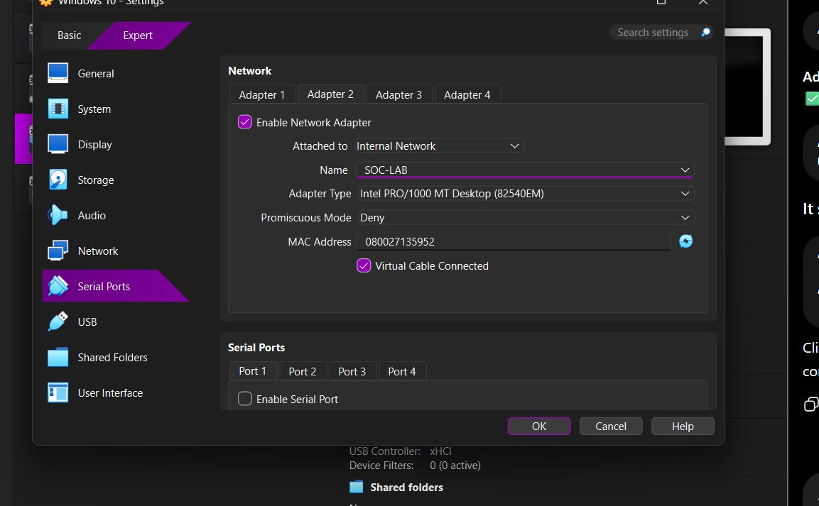
Figure: Kali Linux — FIM simulation commands and Hydra SSH brute force attempt

9.1 Commands Executed
Command | Purpose
echo "hacked" | sudo tee -a /etc/wazuh-test.txt | Create file with content
sudo touch /etc/resume-test.txt | Create empty file
echo "modified by pavan" | sudo tee -a /etc/resume-test.txt | Modify file content
sudo chmod 777 /etc/resume-test.txt | Change permissions (world-writable)
sudo rm /etc/resume-test.txt | Delete file
hydra -l root -P passwords.txt ssh://192.168.56.10 | SSH brute force simulation

Each of these actions simulates post-compromise attacker behavior: modifying configs, creating backdoor files, changing permissions, and attempting lateral movement via SSH brute force.

9.2 Authentication Monitoring
All authentication events were captured and categorized by Wazuh:
- Login successes and failures
- PAM session open / close events
- Sudo command executions
- Root access attempts

Authentication monitoring is essential for identifying account compromise, unauthorized access, and privilege misuse — all critical SOC investigation scenarios.

9.3 Vulnerability Detection
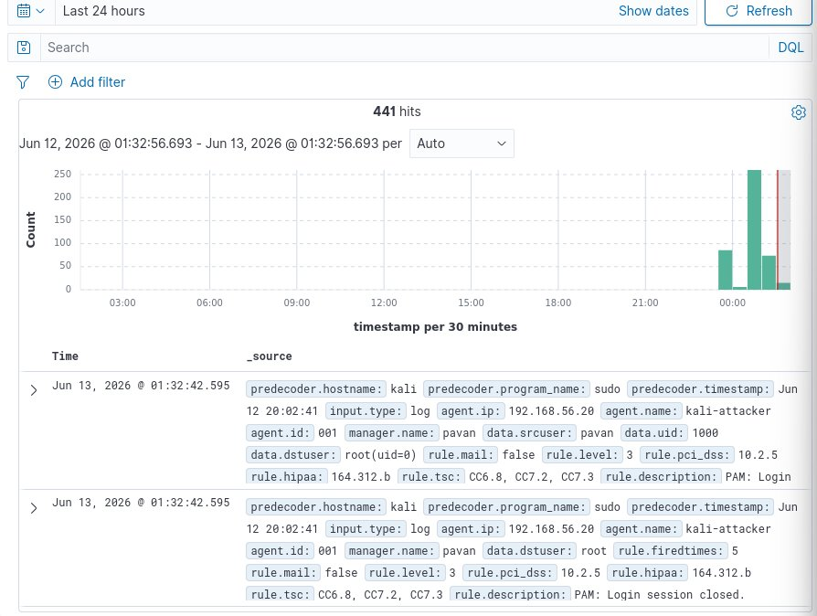
Figure: Vulnerability Detection — No results (baseline clean state)

The Vulnerability Detection module was enabled. The baseline scan showed no results for the kali-attacker agent at this stage, confirming a clean initial state before further testing.

10. Skills Demonstrated

Skill | Evidence
SIEM Deployment | Deployed Wazuh All-in-One on Ubuntu Server 26.04 LTS
Detection Engineering | Wrote custom XML rules (rule IDs 100001, 100500)
Threat Hunting | Used Wazuh Discover to investigate 400+ alerts
Log Analysis | Analyzed PAM, sudo, syslog, and sshd events
Linux Administration | Managed services, networking, disk expansion, LVM
VirtualBox Networking | Configured NAT + Internal Network across 4 VMs
Alert Triage | Classified and investigated alerts by rule level and MITRE
MITRE ATT&CK | Mapped detected activity to ATT&CK techniques
Compliance Mapping | Reviewed PCI-DSS, HIPAA, GDPR, TSC rule mappings
FIM | Simulated and detected file integrity violations
Authentication Monitoring | Tracked login sessions, sudo, and root access
Agent Management | Enrolled, configured, and verified Wazuh agents

11. Future Enhancements
- Vulnerability Detection — Enable CVE feeds and scan for outdated packages
- Active Response — Auto-block malicious IPs via SSH brute force protection and firewall rules
- Suricata Integration — Add network IDS for port scan, exploit, and brute force detection
- Metasploitable Agent — Deploy Wazuh agent on Metasploitable and simulate FTP/web attacks
- Detection Engineering Expansion — Build rules for reverse shells, persistence, and malware indicators
- Custom Dashboards — Build dedicated dashboards for FIM, authentication, recon activity
- SOAR Integration — Connect Wazuh to TheHive or Shuffle for automated playbooks

12. Conclusion
This project successfully deployed a fully functional Security Operations Center Home Lab using Wazuh SIEM, Ubuntu Server 26.04 LTS, Kali Linux 2026.2, and VirtualBox. The environment enabled:

- Centralized log collection across multiple endpoints
- Real-time threat detection with 496 alerts generated
- Custom detection rule engineering (rule 100500 — Nmap Recon)
- MITRE ATT&CK technique mapping
- Authentication and privilege escalation monitoring
- File integrity monitoring and simulation
- Hands-on SOC analyst workflow practice

This project demonstrates practical cybersecurity experience beyond theoretical knowledge — directly applicable to SOC Analyst L1, Security Engineer, and Detection Engineering roles.

Future improvements — Vulnerability Detection, Active Response, Suricata Integration, and SOAR workflows — will further increase the lab's enterprise simulation fidelity.

